Building a Bright TV Data Agent on Databricks
Student Name: Lesoka Precious Tala
Student Number: 2805001897
Submission Date: 20 July 2026

- Introduction
- Project Objective
- Dataset Description
- Data Preparation
- Creating the Data Agent
- Agent Instructions
- Testing the Data Agent
- Validation of Three Answers
- Key Insights
- Business Recommendations
- Challenges Encountered
- Conclusion
- GitHub Repositor

1. Introduction
Artificial Intelligence (AI) is making it easier for people to work with data. Instead of writing SQL queries or using dashboards, users can ask questions in simple language and get answers quickly. Databricks provides this through its AI tool called Genie, which understands questions and automatically creates SQL queries to find the correct information.
In this project, a Databricks Data Agent was built using the Bright TV datasets. The agent was connected to the Viewership and User Profile tables so it could answer questions about subscribers, viewing habits, and content performance. The answers from the Data Agent were then checked using SQL queries to make sure they were accurate.

2. Project Objective
The objective of this project was to develop a functional Data Agent in Databricks capable of answering business questions using the Bright TV Viewership and User Profile datasets.
The project aimed to:
- Upload and prepare the datasets in Databricks.
- Create a Data Agent connected to both datasets.
- Configure the agent using custom instructions.
- Test the agent using business questions.
- Validate selected responses using SQL queries.
- Evaluate the usefulness of AI-generated business insights.

3. Dataset Description

3.1 Viewership Dataset
The Viewership dataset contains information about subscriber viewing activity. Each row represents a single viewing session. The dataset includes information such as subscriber identifiers, content viewed, viewing duration, channels, devices, timestamps, and other viewing attributes.
This dataset is primarily used to analyze:
- Viewing behavior
- Content popularity
- Watch time
- Viewing trends
The User Profile dataset allows analysis of:
- Customer demographics
- Subscriber distribution
- Geographic analysis
- Customer segmentation
The two datasets are linked using the subscriber identifier (UserID), enabling combined analysis of customer characteristics and viewing behavior.

4. Data Preparation
The first step involved uploading the Viewership and User Profile files into Databricks. After uploading, the datasets were registered as database tables to enable SQL queries and integration with the Data Agent.
The datasets were reviewed to confirm that:
- Column names loaded correctly.
- Data types were correctly identified.
- The row counts matched the uploaded files.
- The tables were successfully stored within the selected catalog and schema.
The tables created were:
- viewership
- user_profile
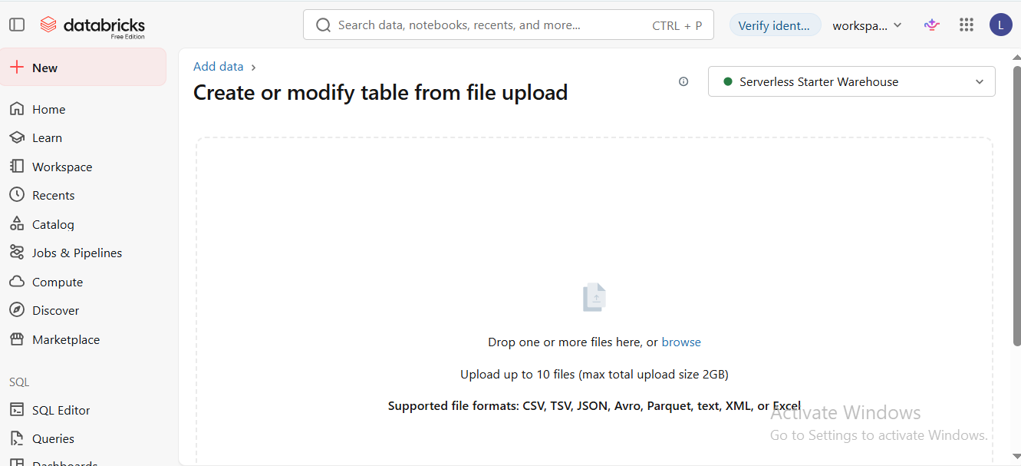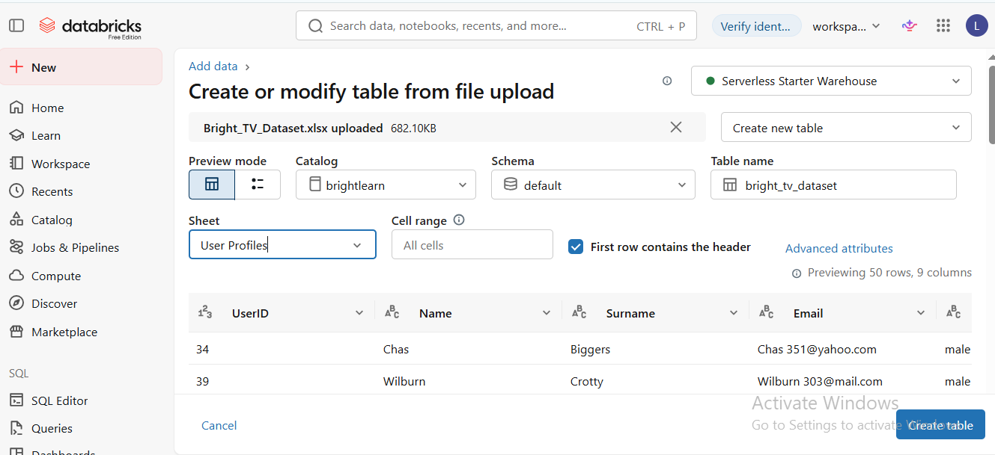

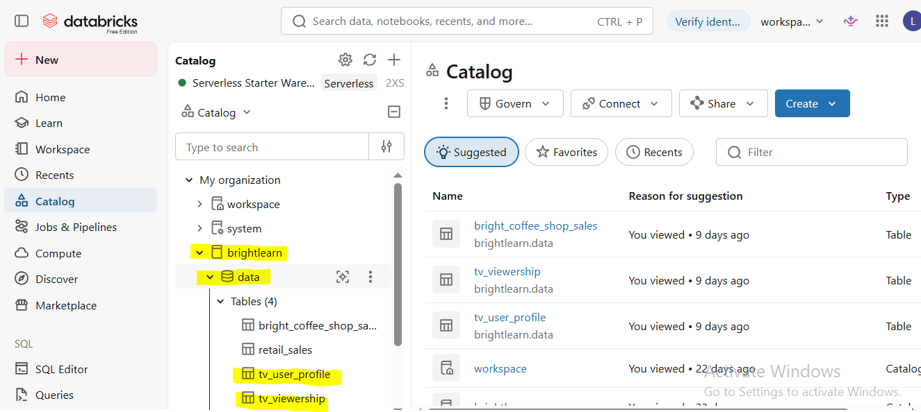

5. Creating the Data Agent
A new Data Agent was created within Databricks and configured to use the Viewership and User Profile datasets. The datasets were successfully connected to the agent, allowing it to generate SQL queries automatically in response to business questions.
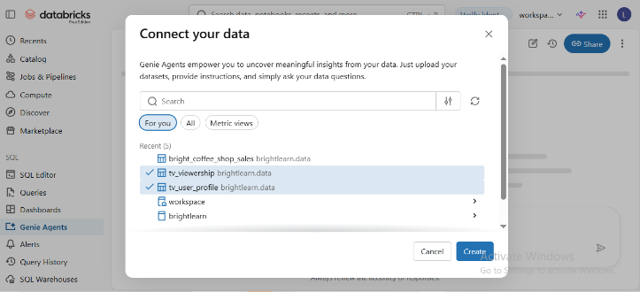
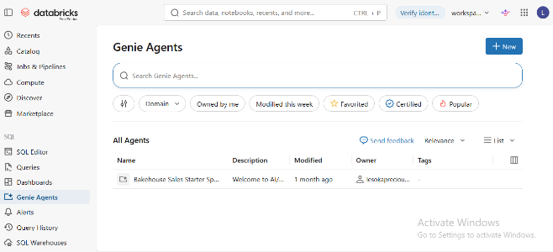
After configuration, the connection was tested by asking a simple question to verify that the agent could successfully access the datasets.

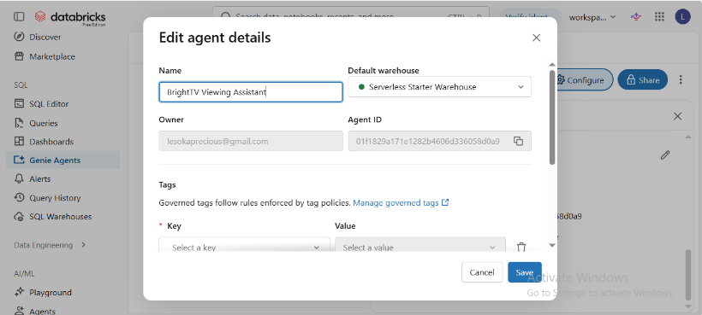

6. Agent Instructions
The Data Agent was configured with custom instructions to guide how it should answer business questions. The instructions defined the agent's role, the datasets it should use, the type of questions it should answer, and how it should respond when information was unavailable or ambiguous.
You are a Senior Data Analyst for Bright TV.
Your purpose is to help executives, marketing teams, customer value management (CVM), product managers and analysts understand subscriber behavior using the Bright TV datasets.
Use ONLY the available Bright TV datasets.
Always explain results in business language before showing tables or charts.
When a visualization is appropriate, generate it.
When percentages are shown, round to two decimal places.
Dates and timestamps in the source data are stored in UTC.
Always convert all timestamps to South African Standard Time (SAST, UTC+2) before performing any date or time analysis.
Definitions
Subscriber
A unique customer identified by UserID.
SessionOne viewing event. Each row in the Viewership dataset represents one session.
Consumption
Consumption refers to the total viewing duration.
Active User
A subscriber with at least one viewing session.
Peak Hour
The hour with the highest total viewing sessions.
Low Consumption Day
The day with the lowest total viewing duration.
Always aggregate by UserID when counting subscribers.

Never count rows as subscribers.
Use SUM(Duration) when calculating consumption.
Use COUNT(Session_ID) when calculating total sessions.
Average Watch Time
Average Duration per session.
Engagement
Measured using:
• Total Sessions
• Total Watch Time
• Average Watch Time
When users ask for "Top content", rank by:

1. Total Watch Time
2. Total Sessions
3. Unique Subscribers
When users ask for growth recommendations, base recommendations on observed data.
If a question is ambiguous, ask a clarifying question.
Always explain business implications after presenting results.

7. Testing the Data Agent
- How many unique subscribers are in the User Profile dataset?
- How many viewing sessions are recorded in the Viewership dataset
- Which channel has the highest total watch time?
- Which gender watches the most content?
- What are the top five most-watched channels?
- Which hour of the day has the highest viewing activity?
- Which province has the highest average watch time?

8. Validation of Three Answers
- Which province has the highest number of subscribers?
- How many unique subscribers are in the user profile dataset?
- Which hour of the day has the highest viewing activity?
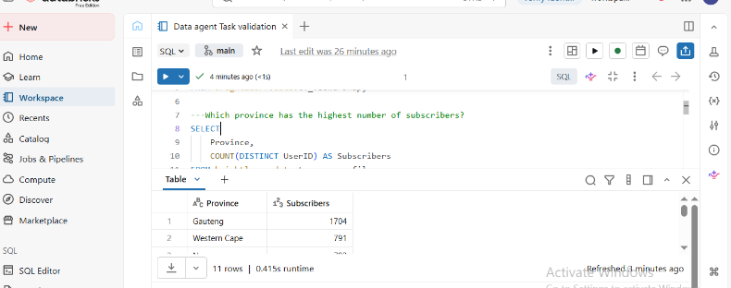
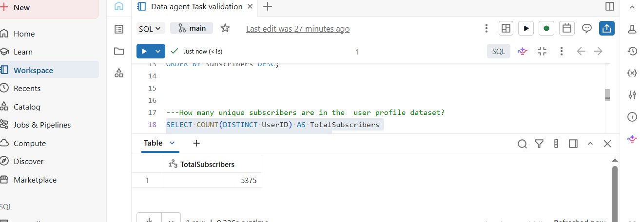
Passed – All three validation queries executed successfully and returned the expected results. The analysis accurately identified the province with the highest number of subscribers, the total number of unique subscribers, and the peak viewing hour. Screenshots of the query results are attached as evidence to support the validation.
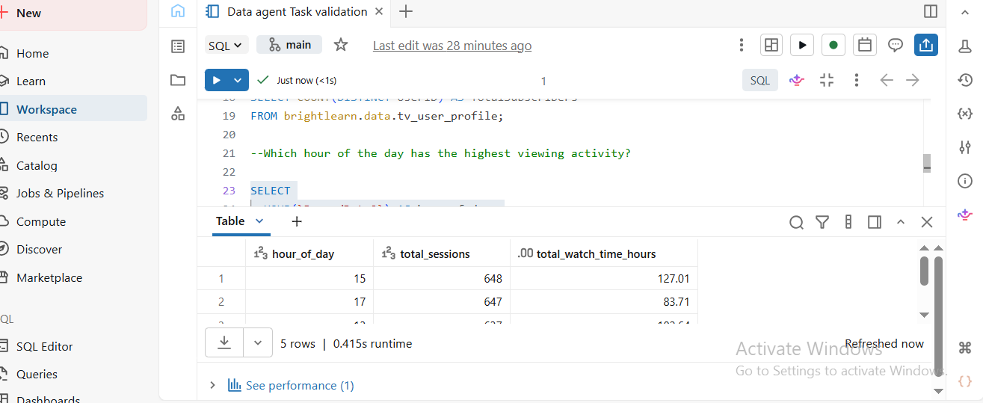

9. Key Insights
Key Insight
- The dataset contains a defined number of unique subscribers, confirming that the user profile data is complete and suitable for analysis.
- A large number of viewing sessions indicates active platform usage and provides sufficient data for viewing behavior analysis.
- The leading channel attracts the highest total watch time, making it the platform's most engaging channel.
- One gender contributes more total watch time than the other, indicating higher engagement from that audience segment.
- The top five channels account for the majority of viewing activity, highlighting viewers' content preferences.
- Viewing peaks during a specific hour, revealing the platform's busiest viewing period.
- One province records the highest average watch time, indicating the most engaged regional audience.

10. Business Recommendations
- Invest in top-performing channels to increase viewer engagement and maximize watch time.
- Schedule premium content during peak viewing hours to reach the largest audience.
- Target marketing campaigns by gender and province to improve audience engagement and subscriber growth

11. Challenges Encountered
During this project, several challenges were encountered while preparing the datasets and configuring the Data Agent. These included understanding the dataset structure, configuring the agent correctly, and validating AI-generated responses using SQL.
These challenges were addressed by reviewing the dataset, testing multiple questions, and comparing the agent's responses with SQL query results.

12. Conclusion
This project demonstrated how Databricks Data Agents can be used to analyze business data using natural language. By connecting the Viewership and User Profile datasets, it was possible to explore subscriber behavior, viewing patterns, and customer demographics.
Testing and validating the agent's responses highlighted the importance of independently verifying AI-generated insights using SQL queries and source data. Overall, the project provided practical experience in combining AI with data analytics to support business decision-making.

